|  |
| --- |
|  |
| Assignment 4  RBLCAM001 |
| |  |  |  | | --- | --- | --- | | Cameron Rebelo | 8/10/21 | CSC2002S | |

## Overview:

This design is focused on assisting young children in how to read and tell the time. The design choices made here were made with that in mind and the decisions were informed by the data that was collected through the interview process. The interviews provided valuable insights into the needs and features that should be incorporated into the app and thus a key problem was identified. Children need an app that is fun and interactive to use because children learn best through engagement and entertainment. Children also need an app that is widely accessible and representative because it is important to accommodate all people and not exclude anyone from learning.

The app is designed for children to use but to narrow down a target audience, it would be specifically for grade 1 – 3 children who are learning to tell the time. The app would be specifically south African and would aim to meet the South African standard of the teaching curriculum. This also means that the content within the app would aim to be inclusive of all South African children, with pictures and art being representative of South African culture and people. This would be shown as people included in the graphics that represent a variety of cultures and backgrounds within the app. The interviews also revealed a key factor to consider ion that the app should be the app will also aim to make itself as accessible as possible for a variety of impairments including colour blindness, deafness, sight impairments and other things. This is so that no member of the target audience feels like the app isn’t accessible to them. It is our job as app designers to think of these needs and include features to help. Some assumptions that were made is that every child that uses this app will be enrolled in school. This means that we can assume that the children can read and write basic sentences in their chosen language and that they will be able to understand the basic problem solving needed to address the problems.

The overall design will incorporate these features to address the needs of the users. The app will include a recorded song that will give simple instructions to teach children how to perform a dance to the song to help them to learn time. This is done so that the app forms a fun and interactive learning base for children that will help them to learn more effectively (Griffeth, 2020). The app will also include accessibility features, for this assignment these needs will be grouped as one feature. This feature includes a voice command that will read the text on-screen on loud and provide instructions, colour palette choice, language choices and an ask the teacher for assistance button. As mentioned before, it is very important to make the app as accessible as possible and these features are aimed at improving the experience for children who may have impairments. This also addresses the problem statement about children needing an app that is accessible. Finally, the last feature that will be included in the app is the learning feature that will consist of a short video explaining a topic about reading time followed by a short multiple-choice test with lots of graphics and visual stimulus. This feature addresses the need to have a fun and interactive app and the need to include representation in the app as the graphics used will be a representative display.

## Overall Design and Layout

The application starts with the screen where you choose what language you want the application to be in (screen 1). Once you choose a language, you will press the green button to confirm your choice (screen 3). The app will then transition to a screen where the user will input their name and then confirm it (screen 4). The drawer stack that is always present throughout the app in the top right corner will pull out the drawer as seen on screen 2 that has useful features for settings in the app and to call the teacher for additional help. The user will then be directed to a screen where they will choose what they want to do in the app (screen 5). They will either choose to learn or to listen to music. When clicking the music button, the user will be directed to screen 6 where they will have some further options. They can view the song and performance by clicking on the song button this will direct them to screen 9. The dance button will transition them to screen 7 where they can record themselves, after which they will automatically be transitioned to screen 10. Should they wish to rerecord, the start again button will return them to screen 7. The submit button on screen 10 will add the video to the class library and return the user to screen 6. The watch friends’ button will take the user to screen 8 where they can see the videos of everyone in their class. Back on screen 5, if the user presses the learn button, they will transition to screen 11. When the user makes a choice on which section they would like to learn, they will be directed to screen 12. Once the video has been watched, the begin button can be pressed and they will be taken to screen 13. If the wrong option is chosen, the user will be shown screen 15. After all the test questions are answered, they will be taken to screen 14 where they can see their final score and then press the finish button to return to screen 11.

# Feature 1:

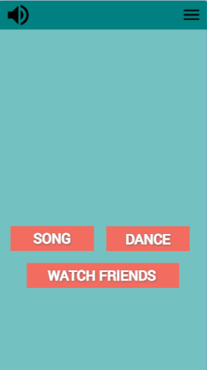The app needs to be fun and interactive so that it addresses the statement of children needing a fun way to learn how to tell time. This feature aims to address that by providing the children with fun songs that they can make dances to. Those dances can then be recorded and uploaded to their classmates so that everyone can see each other having fun and participating. Studies show that this kind of interactivity within mobile apps especially helps with learning and development. This feature was also well received in the interview process and the interviewees were excited about the idea of using movement to learn as well. The overall design of this feature is to provide two functions: the children watch and/or read the lyrics on the screen as a video showing a pre-recorded person demonstrating movements that are linked to different times plays (e.g., stretching when making up to show 7 am) and then students recording themselves whilst the song/lyrics play and then the students can move along with the video. The second function will also then allow for the video to be uploaded and shared with the rest of the class if internet connectivity has been enabled.

Figure 1

Button that takes user to screen where they can see all other submitted videos

Button that takes the user to the screen where they can record and upload themselves

Button that plays the video and lyrics to the pre-recorded song

Figure 1 shows the menu where the two different functions are shown. The principle of least effort is applied here as the design is kept as simple as possible. The only interactable icons here are the functions that we want the users to choose from and the features that persist throughout the app. The song button will take the user to the screen where they can watch and read the lyrics of the song and performance that will be pre-recorded. The dance button takes the user to the screens where they can start filming their dances and videos. Lastly, the watch friends’ button will take the user to the screen that shows the videos of everyone in the class who has submitted their video. Another point to note here is that a graphic has been used to add context to what these features are related to, this is where we address the need for representation as the humans that we show in these graphics should represent a variety of cultures and ethnicities. The clipart that is used in this prototype is from someone else's design on the internet but for final designs, the app should have custom art made to suit its own needs as a South African app with South African cultures represented in it.

Button that returns user to fig 1

Lyrics matching what is playing in the video

Video player with player controls

Figure 2

Figure 2 is the screen that plays the video that the children will watch. What is important here is that the video is accompanied by the lyrics as well so that there are options for whether the students can watch and listen or read along if they are not able to. The video would be performed by an actual human and editing would be done to make cool animations whilst singing a simple and catchy song in different languages. The video player will come with the standard controls of play and pause and the time slider as well as the ability to make it full screen. These controls are meant to give some level of control for the child to choose how they would like to consume that content. When they are done with the video, the finish button will return them to fig 1.

Start recording button

Lyrics to the song

Camera playback

Figure 3

In figure 3 we can see the interface for recording the children dancing to the song. The whole screen will be made up of the playback from the camera. The only functionality on this screen is the record button that will start the playback of the song and display the lyrics on the screen as the song plays. The child will then perform their dance or movement to the song as it happens, and it will be recorded. Once the recording ends, the screen will automatically switch to figure 4 where the user will be shown their video to themselves. This screen keeps the design as minimal as possible as this task requires concentration from the kids and as the interviewees have stated, children often get easily distracted by things. By making the screen only play the camera feedback, there is nothing else for the child to focus on except for pressing the record button which will play the song and start the lyrics, thereby giving a visual and auditory cue on what they should be doing. Making the screen switch at the end automatically also helps with simplicity and removes the possibility of user error.

Figure 4

Playback of video just recorded

Button to start recording again

Button to submit video to class group

Figure 4 shows the confirmation for the video submission. The video that was just recorded is played back to the user so they can watch themselves and decide whether to press the start again button (which will return them to figure 1**)** or the submit button that will post the video to the class group and move the user onto the next screen. The choice to use the green submit button is to keep in the design principle of consistency and persistence as in other places in the app when a choice needs to be confirmed, a green submit button is used. Again, the screen is kept relatively simple with few buttons to ensure simplicity in the decisions that need to be made. In the final version of the app, when graphics and other such choices are finalised, I would also include some of the human elements here as discussed in the interviews. The interviewees identified that having humans represented in the app will help the child engage more. This would be achieved by putting a person pointing to the submit button or something similar.

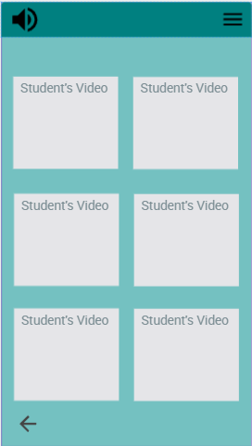

Thumbnails of videos of other students.

Back arrow to return to figure 1

Figure 5

Figure 5 organises and displays all the submitted videos of students in a particular class. The videos will have the names of each of the students on the thumbnail and clicking on one will make it full screen. The design is simple here and aims to show off as many people’s videos at once without getting too small. The back arrow is a universal device icon that will return the user to figure 1.

# Feature 2:

Accessibility is an important feature that I want to include in my app and so I have made design choices that incorporate as many ways as possible to provide that accessibility. The choices I have made in this feature were informed by an article on making better apps for everyone by Yasmine El-Glaly (El-Glaly, 2018). The things that were taken into consideration were: language accessibility, visual impairments, colour blindness and audio impairments.

Labelled buttons with different language options on it

Text to speech button that gives instructions in words and reads the information on the screen

Burger stack menu button that opens menu in figure 7

Figure 6

Figure 6 is the first screen that the student is shown when they open the app is a screen with a series of buttons that allow the learner to choose what language they would like the app to be in. This addresses the language accessibility option as all 11 official South African languages are shown here. From a developer’s point of view, this might seem daunting due to having to make instructions in so many different languages but because the instructions throughout the app will be concise and simple, we don’t have to worry too much about that. Each button is large enough on the screen and given enough space between buttons that it would be difficult to click the wrong one if you were intending on choosing an adjacent button.

The other accessibility feature that we can notice on this page is the text to speech button located on the top left corner of the screen. This is a principle of least astonishment choice that provides some consistency across the app. That feature will always remain in the top left corner of the app and will always do the same thing. The purpose of this feature is to read aloud the instructions that are required for the current page and read the information that is currently displayed on the screen. This feature is aimed at helping children who are more visually impaired and therefore can’t always see as well. The icon used for the feature is the standard audio icon and the children should be able to understand that pressing it will play some sort of sound out loud. An edge case of this feature is if the user presses the button on the first screen before any language is chosen. Normally the voice would give instructions in the users chosen language but, in this case, the instructions will cycle through the languages until the user chooses one.

Toggle slider to change the colour palette of the app

Figure 7

Close the menu drawer

Button to ask for assistance from the teacher

Button to access further settings in the app

Figure 7 shows the menu drawer that is shown when the menu stack icon is pressed in the top right corner of the screen. This panel slides out from the right of the screen and is designed in this way as it follows android protocol of a navigation drawer (Google, 2021). The purpose of this drawer is to provide additional access to features that we don’t always want on the main screen. We hide these away to declutter the screen and provide fewer buttons for the children to click on at any given point. This drawer is a different colour to differentiate it from its background and the background also greys out to show that those buttons are not interactable while this drawer is “pulled out.” The most important accessibility feature in this menu is the different colour slider. This toggle on and off switch gives the user the option to change the colour palette of the app with a simple slider. This is done so that if a user finds it difficult to read the screen due to the colours, there is an alternate palette that would make it easier for them to see.

Selected Language

Confirm Button

Figure 8

Figure 8 addresses an issue that a user with auditory impairments might face. We are using visual feedback to show the user what they have selected and give them a choice to confirm that selection. This is also one of the golden rules of design as we are providing the user with information about what they have done. This method allows learners with hearing problems as the app doesn't really on auditory clues to provide confirmation.

# Feature 3:

The app needs to be fun to learn from so the last feature will be a section where kids are shown fun graphics and/or videos about a time concept and then will be given a multiple-choice question(s) to answer based on what they just saw. These videos will feature people explaining things such as quarter past and hours with animated visuals as a guide. The videos will be shown with subtitles as well. After the video has played, the user will then click the begin button to start a short multiple-choice test. The test will show various graphics and questions and give the child simple easy to choose from answers. The screen will then wither display right or wrong and explain what the problem was if they were wrong. At the end of the test, the child will be presented with a score that will tell them how many they got right in total and then will redirect back to the screen with the different sections.

Figure 9

Checkmark to show which sections have been passed successfully

Buttons showing various sections for the children to choose

Figure 9 is the main screen for this feature. It shows the different sections that are available to watch and learn. In the final version of the app, more sections can be added but for now, this will do. The graphic art of the sections can also be more interesting, incorporating pictures and little doodles relating to that section in the head will make it more entertaining for the children to look at. For this prototype bright colours were used to make it more entertaining for the kids to look at. The screen keeps to the minimalist style by combining the name of the section onto the button that will take you there. There is also a tick mark next to the name of the section that will appear once a student has successfully passed a test in that section. The back button also persists here and is placed conveniently in the lower corner and will take the user back one screen.

Figure 10

Back button to return to figure 9

Subtitles of video

Button to start test

Video of concept

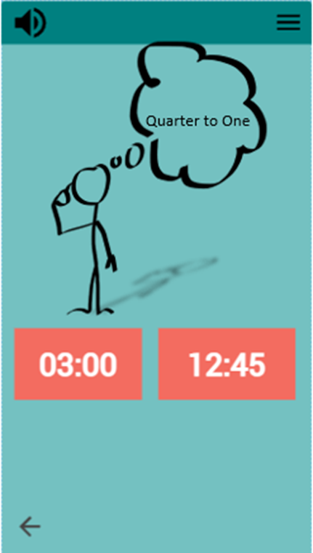This screen is the first thing that the user will see when they choose a section. A video will play here that will describe concepts related to the section. The begin button will be locked until the user has watched the video at least one time. This is done to minimize user error by making sure that the children are shown the required content first before being tested. The screen is similar to the video that is played for the dance in feature 2 and this familiarity is intentional to align with the principle of persistence. The begin button then takes the user to the test on that section.

Back button to return to figure 9

Buttons to choose answer

Figure 11

Figure 11 is the testing screen that is used to give the multiple-choice questions to the child. The buttons are made big and bright so they can easily distinguish between the options and the graphic is kept simple. The back button persists to quit the test at any point.

Text showing result of the test

Button to proceed back to figure 9

Button to proceed to next question

Text explaining concept they got wrong

Figure 13

Figure 12

Figure 12 is used to show the user what they can learn more of when they get a question wrong. The interviews revealed that children will get frustrated when they get something wrong, and that frustration often stems from confusion. This screen therefore helps to clear up some of that confusion by explaining to the child what they got wrong and how they can fix it. The “next” button is the only interaction on the screen and will take the user to the next question. The button is made large, so they know this is the only way off this screen.

Figure 13 is the screen that is shown to the child after the test and displays the final score that they achieved for the test. A fun graphic with people will make this screen more exciting in the final version. The “finish” button is the only interactable object and will return the child to the screen to choose which section they want to do.

# Addendum:

Link to miro board for overall design flow diagram:

<https://miro.com/app/board/o9J_lr-Pg6M=/?invite_link_id=746201024573>

I have made an interactive version of the flow of the app using Fluid UI. Please note that I could not add any of my own pictures on the website with the free version. Please click Xhosa as your language to start. Find the link below:

<https://www.fluidui.com/editor/live/preview/cF8zVHlwOWNxa0xBRW9RMVowN3lJM2NjeVVUS2RJaHMyQg==>

# Reference List

El-Glaly, Y. (2018). *Apps for Everyone:Mobile Accessibility Learning Modules.* ACM Inroads.

Google. (2021). *Navigation drawer*. Retrieved from Material Design: https://material.io/components/navigation-drawer

Griffeth, S. (2020). *Apps as learning tools: a systematic review.* Pediatrics.